A History of Scouting in Hoveton and Wroxham

Compiled by Nigel Pope
1st Hoveton and Wroxham Sea Scouts

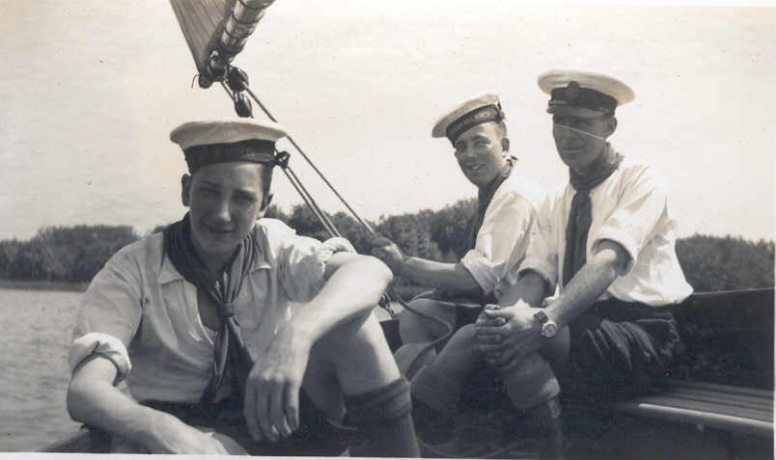
On Wroxham Broad 1937

Introduction
A Scout Group is immortal, a constant supply of new members ensures that it forever young. However, this constant turnover of members means that people join, do good deeds in its name and then move on. Lots of Scouting gets done but the history is quickly forgotten. Questions like "where did we come from?" can be hard to answer. Even asking “what happened 10 years ago?” can be an impossible question.
The 1st Hoveton and Wroxham Sea Scout Group has got a long history, but actual paper records are in short supply. This book is the result of research carried out by Nigel Pope in 2003. The information has come from many sources and every effort has been made to verify its accuracy. However, there is still a lot to learn. The research work is still continuing and this book will be updated as new data comes to light. The latest information can be found on the Group website at www.btinternet.com/~n.pope/1home.htm
We hope you find this history interesting and you enjoy looking at the old photographs. If you have any information which may be able to help us improve our records, please let us know.

Geographical Note
The twin villages of Hoveton St John and Wroxham are in the East of England in an area known as The Norfolk Broads. Actually they are one village cut in half by the River Bure. The area to the north of the river is Hoveton and the area to the south is Wroxham.
Visitors to the Norfolk Broads will be very familiar with this area as it is a popular stopping place for holiday makers on boats. It sometimes calls itself “The Capital of The Broads”. The centre of Hoveton is dominated by the various shops which make up Roys Department Store and has always been the most familiar part of the village to visitors. Despite this, the village as a whole is often referred to as Wroxham. This can be confusing and this confusion is reflected in the various names given to the local Scout Group as you will see. I have tried to use the correct names throughout this book and I hope this makes it a bit clearer.

Who Wrote this Stuff?
This book is a compilation of historical information from the Group Archives. Where the author is known, this is clearly indicated in the text. If the author is unknown then this is also indicated. You can assume anything else was written by Nigel Pope.

Significant Dates
The following dates list key events in Hoveton and Wroxham Scouting.

Wroxham Scouts registered at Imperial HQ for first time - 2nd Sept 1910
Wroxham Pack registered - 30th Sept 1920
North East Norfolk District created - 1926
Changed name to Wroxham Scout Group 1928 when Groups first started
The Chief Scout awarded the Silver Cross to P.L. Jack Howes for gallantry in attempting to rescue a man from drowning in the River Bure. - 1928
Changed name to 1st Wroxham Sea Scouts - 1932
Group inspected by BP aboard HMS Implacable. – 1934
Last known records of 1st Wroxham - 1948
Group re-formed as 1st Hoveton and Wroxham Cubs - 1966 Meetings held in the Garage at St John’s Vicarage.
1st Hoveton and Wroxham Sea Scouts start meeting 6th Feb 1968
Work starts on new HQ at Hoveton Village Hall.- 1968
Venture Scouts formed - 1985 (folds again in 1988)
Work starts on new HQ building - 1985
Group moves to new HQ in Nobel Crescent Wroxham - 1987
Venture Scouts re-formed - 1993
Beaver Colony formed – 1993
Female Scouts for first time - 1997
Explorer Scouts replaces Ventures - 2002

A Brief History

In the Beginning .....
BP held his experimental camp in 1907 and his book Scouting For Boys soon followed. This created a wave of enthusiasm for Scouting and many Scout Groups were created over the next few years.
The 1st Wroxham Scout Group was one of these early Groups and was registered on 2nd September 1910. Initially, the Troop met at Wroxham Hall which was in the area where Charles Close now stands. The owner, Colonel Charles, was a good friend of BP who was a regular visitor to the Hall. It seems that the two friends often sailed together on Wroxham Broad. BP presented a new flag to the 1st Wroxham Group in person in 1914, perhaps on one of his visits to the Hall.
Between the Wars ....
The Great War caused considerable disruption to Scouting in Wroxham with many leaders away on war service. However, after the war, the Group resumed normal activities with new leaders and a new location. The new HQ was in Caen Meadow on land owned by Wroxham Council. It was an excellent location next to the River Bure with a slipway for launching boats. The Group leased this land on a yearly basis and the rent was £1.
A key member of the Group in this period was Eric Stevenson, a well known local blacksmith. He eventually became Scout Master and his excellent photograph album are now in the Group archive showing an active Group with lots of camps and boating activities. Many of the photographs in this book come from this album. Here are a few events from that period
1922. H. Lane was SM with 13 Scouts and Mrs Gilbert was CSM with 18 Cubs
1924. The Group camped in the grounds of Harrow School as part of the Wembley Jamboree. (Col Charles was a former pupil of Harrow)
1926. North East Norfolk District was formed. Joan Astley was now CSM
1928. Scout Groups come into being for the first time. Wroxham Scouts registered as group number 7390. P Hemingway is now SM and A.E. Hemingway becomes Rover Leader. The Chief Scout awarded the Silver Cross to P.L. Jack Howes for gallantry in attempting to rescue a man from drowning in the River Bure.
1930. Troop attended the City Jamboree and won a Certificate of Merit
1932. Group changes name to 1st Wroxham Sea Scouts. Miss D Brooks now CSM
1933. GSM is now Mr S.A. (Rajah) Brooks and SM is J.H. (Tadpole) Braybrooks
1934. Eric Stevenson becomes ASM. Group inspected by BP aboard HMS Implaccable (Portsmouth)
1935. Capt H.J. Cator becomes GSM
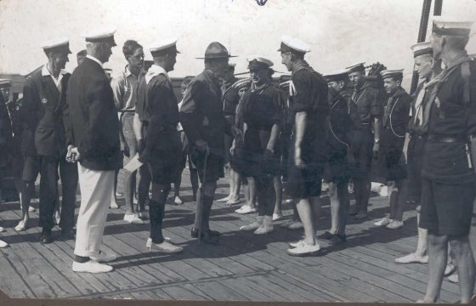
BP Inspecting on board Implaccable
Uncharted Waters ....
The Second World War was another difficult period for Scouting. The 1st Wroxham records show that the Group continued to operate throughout the war but with reduced numbers. The 1st Wroxham supplied people to the Army, Navy, Merchant Navy and Royal Air Force during this period. However, the Group survived and was still operating up to 1948.
In 1948, the 1st Wroxham Group closed down and the HQ building in Caen Meadow was sold for £80.00. The reasons for this are unclear and it may be that there was simply a lack of support that this time. Guides did continue to meet at Caen Meadow for a while afterwards.
Shirley Ebdell moved to Hoveton in 1949 and when her son Martin was 8 in 1966, she tried to find a place for him in a Cub Pack, but none was available. Barbara Bennett suggested that Shirley became a leader and started a Cub Pack to fill the gap. Shirley agreed to do this and so she became Akela and subsequently her husband John Ebdell became Assistant Scout Leader with Graham Noble as GSL. The Group adopted the new name of 1st Hoveton and Wroxham partly because the meetings were held in Hoveton and partly because adding Wroxham to the name enabled the new Group to claim the money from the sale of the Caen Meadow HQ. A committee was formed and the early meetings were held in the Vicarage garage in Horning Road Hoveton. From this beginning, a prefabricated building was purchased and placed in the Grounds of Hoveton Village Hall. It was small and not ideal, but it did allow the Group to get going again and soon very good progress was made in all areas of Scouting.
A home of our own ....
The building in Hoveton was really too small for the Group's needs and there was a time when meetings were actually held in several garages scattered round the village and connected by CB radio. This was an unsatisfactory arrangement, and following an arson attack while the Group was away at camp it was decided that a new HQ had to be found. Building your own HQ is no small undertaking and it involves a lot of investment of time and effort, not to mention a huge fund raising operation. However, under the guidance of GSL Tony Davey and Chairman Barrie Mortimer, the Group pulled together and in 1987, the 1st Hoveton and Wroxham moved again, this time to its new purpose built HQ in Nobel Crescent Wroxham.
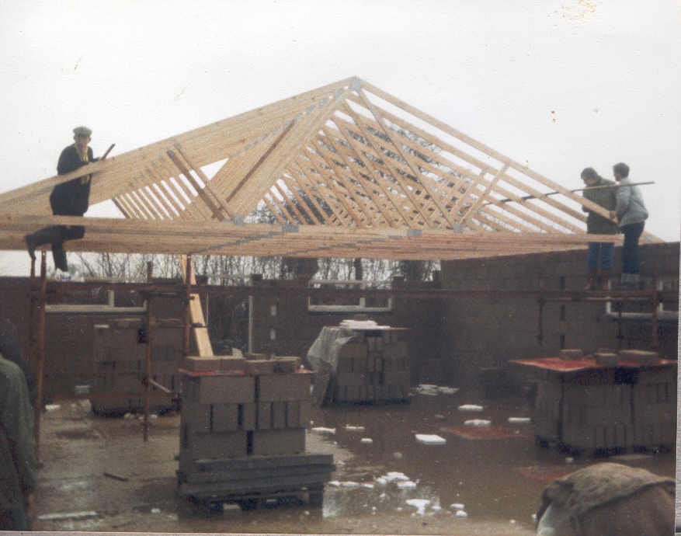
The new HQ takes shape

Here are a few events from the 1980s and 1990s (information supplied by Fred Crane, former SL and GSL).

84. Enterprise sailing boat purchased
85. 3 chief scout Awards. (Gordon, Lee and Peter)
Ventures formed.
2 more sailing boats and 10 life jackets purchased
86. 3 more Chief Scout Awards (Chris, Graham and Glenn)
Won District and County Wayfinder competitions (Graham Pye) (1st time in 20 years by Broadland District)
87 Barry awarded Chief Scout’s Commendation
Won County Cooking competition – Andrew Doyle
88 Ventures folded. Julian GSL, Fred SL Norma CSL
89 Purchased 10 plastic canoes + paddles and buoyancy aids
Won County Cookery Competition (Malcolm McKee)
90 Won District and County Wayfinder Competitions (Malcolm McKee) Fred Crane now GSL
91 Won District + County cooking comp. Richards – Medal of Merit.
92 Second hand small buoyancy aids
93 Ventures reformed Gordon VL, Leslie AVSL
Beavers formed Norma BSL, David CSL
94 100 boys in Group, Awarded St George’s Flag. Built ramp for disabled at HQ, 15 new buoyancy aids
95 Activity room. Won St George’s flag Ventures to Euro Venture in Paris.
96 Purchased 2 Toppers
97 Purchased 1 Topper. Won St George’s Flag. Girls in Scouts. Ian Mercer becomes Queens Scout, Romena Marshall CSL, Terry Hughes SL.

Other Historical Information and Records

The Early History of Wroxham Scouting
From a note written by Eric Stevenson when he presented this photograph of BP to the 1st Hoveton and Wroxham Group at the dedication ceremony of the new HQ building in Nobel Crescent..

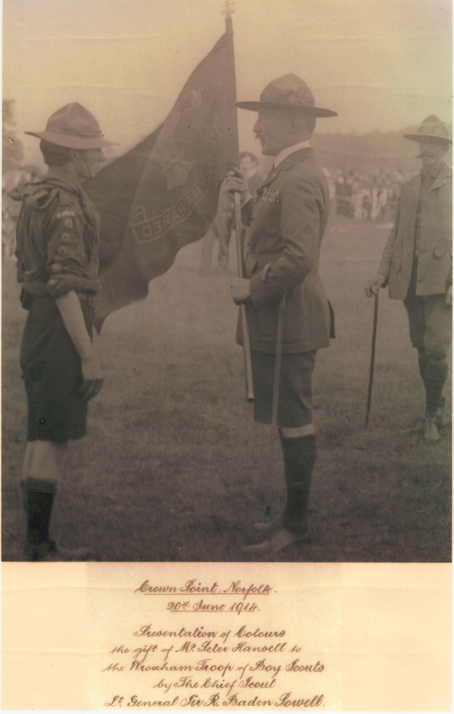

This framed photograph of Lt. General Sir Robert Baden Powell, who was the first Chief Scout, was given to me by the auctioneer Mr J. R. E. Draper, when the contents of Wroxham House were sold after the death of Col. S. F. Charles
The first Wroxham Troop of Boy Scouts were formed in 1910 as a result of the close friendship between the two Army Officers whilst in Africa, and the Chief Scout often
visited Wroxham House and sailed on Wroxham Broad.
Col Charles, who eventually became a Scout Commissioner, was the first Scoutmaster for the Wroxham Troop and Mr Harry Lane, who worked and lived on the estate became ASM and can be seen on the right hand side of the photograph. Stanley Davies seen here receiving the flag was the eldest son of Mr G. M. Davies who was headmaster of Wroxham School and also Scoutmaster in my early days of Scouting. Stanley Davies joined the army and was killed on active service during the early period of the Great War, 1914 -1918.
I became a member of the Peewit patrol in 1919 and finished my scouting life as the Scoutmaster of the 1st Wroxham Sea Scouts in 1940 when our headquarters were in Caen Meadow.
It gives me great pleasure in presenting this photograph to the 1st Hoveton and Wroxham Sea Scout Group for their safe keeping and I hope that they will carry on the great tradition of Scouting in this area for many years to come.
Eric A Stevenson. Wroxham. 28th June 1986.
Presented at the dedication of the new headquarters at Nobel Crescent Wroxham

Kayak Notes by Eric Stevenson 1932

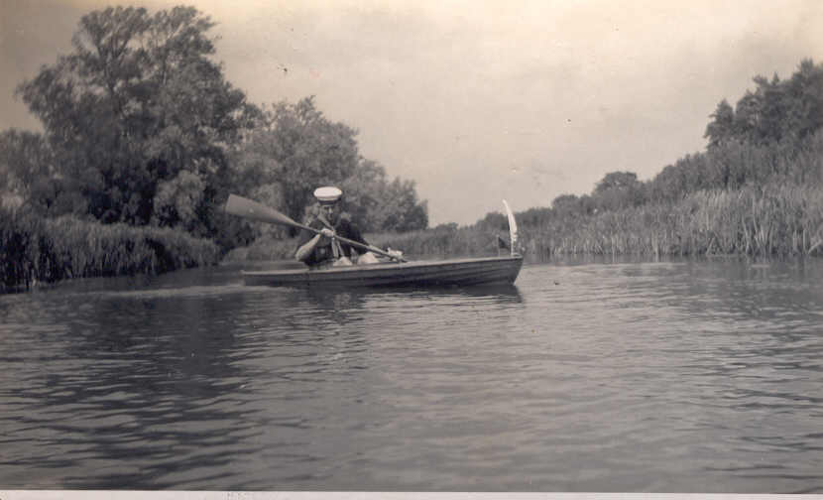

This photograph was taken at the South End of Wroxham Broad near Hospital Farm Salhouse in 1932. It shows Rover Sea Scout Eric Stevenson of Holly Lodge Wroxham.
I bought the kayak from J.R.E Draper’s boat sale for £17-0-0. Quite costly at that time. She was built by a boat builder and was quite heavy – solid wood throughout, no plywood at all. The paddle I made from 2 oars jointed in the centre for easy storing. The stem was of oak and was split when I bought it, but Rover Scout Jack Parnell (a boat builder by trade) fitted a new oak stem and made a perfect job of it. The swan’s feather on the boat was I picked out of the water was fitted to the stem and later on I made it into a quill pen for writing. About the same time I had made a water bicycle which I used on the river and broads. The furthest journeys were: Holly Lodge to Coltishall and back and Wroxham to Horning Ferry and back. Both journeys took 2 days each as the speed was quite low. 2 to 3 MPH.

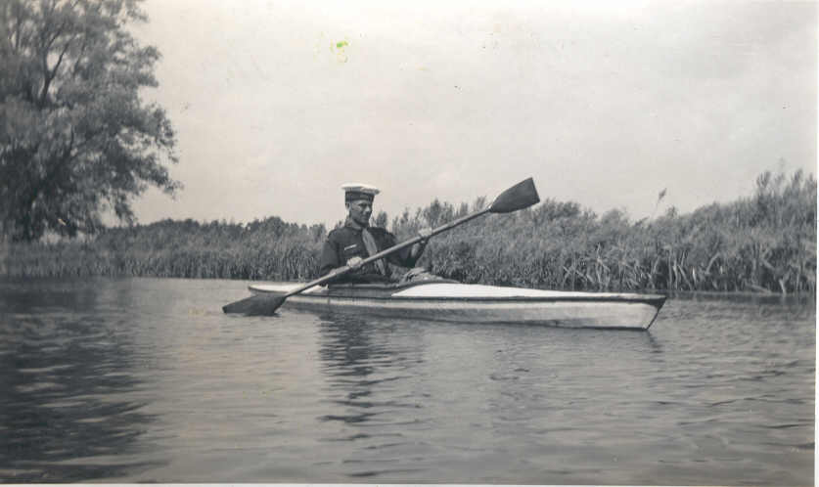
Jack Parnell
In 1933, Jack Parnell and myself set out from the Scout Den at our HQ in Caen Meadow early on a Saturday morning to explore upstream from Coltishall Lock and Horstead Mill as we had not yet journeyed beyond there by water. We managed to get up to Buxton Mill itself, not the side stream. As this took all day, we decided to get back to the Coltishall Lock, leave the kayaks there (Jack used the Scout’s Kayak) and walk back to HQ. We returned next morning (Sunday) return by water in the kayaks.
My kayak was very heavy and we had quite a job to carry it round Coltishall lock (both times) as the lock has not been used for a very long time. The paddle was originally 2 oars from a Cambridge racing skiff which I got from Draper’s sale The 20ft racing tub (they called it) cost me £2-10-0 (a bargain) and it had 2 roller seats which I converted to 1 roller seat. Jack helped me to restore and varnish it to perfection.

The Rover Log. 1938 to 1940

Introductory Note by Nigel Pope
It can be very difficult to get information about what went on at Scout meetings in the past. Fortunately, the 1st Wroxham Rover Crew kept a log book of their activities and meetings at the Group HQ in Caen Meadow. Not only was this a very interesting period of our history, but also, the book gives a fascinating insight into just what Scouting was about at that period.
The notes are hand written in an exercise book. There are two authors. The first part is written by Mr K. B. Curson who clearly signs each entry. The author of the second part never mentions his name, but it can be deduced that it is Rover Scout Jack Points.

A Meeting Held in the Den, Oct 17th 1938.
It was agreed to start the Rover Crew again. The members were:

K.B.Curson SM
Rover K Lasham
J Parnell ASM
Crew – R Squires, G Kidd, M. Hall, E Gotts

SM Curson agreed to take over the subscriptions and the Rovers Mates job. Total subscriptions to date £5/13/9. 10/- left at Den for petty expenses. Amount retained by Curson £5/3/9.
Jobs to be done were:
Repairing the gate
Repairing the step to the Rover Den
Repairing the den store
It was agreed to repair the store first. Material to be obtained by RM. RM stated that he would ring up Mr Gilbert to see when a suitable date for a whist drive could be arranged.
K.B. Curson

A Rover meeting Oct 24th 1938

Present – R.M. Curson, Parnell, Lasham, Kidd, Hall, Gotts

With the aid of copper wire and fire cement, the stove in the big room was satisfactorily repaired by Lasham and Parnell. Meanwhile, Curson painted a small table and several letters for a sign to be put outside the Den – “Rover Den”. Kidd, Hall and Gotts cleaned the dens out and did odd jobs. A game of darts completed a useful evening. Subs were paid up to date.
K.B. Curson

A Rover Meeting Oct 31st 1938

Present – Curson, Parnell, Lasham, Gotts, Kidd and Hall

Parnell and Curson arrived first and cleared the bunks away so that we could get the skiff in for repairs. Also they swept the floor and put the coke in boxes. When the others arrived, Duke cleaned up and got an oil stove to work, Lasham climbed on the roof and took the wind indicator down – he intends to fix up the wind gauge again. Gotts bailed the boats out. Hall cleaned and filled the lamps. Curson and Parnell measured up the gate for new uprights and supports and also calculated what wood was required for a new step to the Rover Den. After this Lasham took the three younger boys in some morse practice while Curson and Parnell discussed the possibility of repairing the half decker. They agreed to repair and paint the skiff first and then see after the half-decker later on. The skiff is to come in the den for repairs next week.
A game of darts again completed the evening.
K.B. Curson

A Rover Meeting Nov 7th 1938.
Presemt – Curson, Lasham, Kidd, Hall and Gotts

Parnell came down for a few minutes to talk to Curson re Armistice Sunday then left. Curson brought the wood down to repair the step. All lent a hand and the job was completed inside an hour. A complete new step was made. The “ROVER DEN” board was screwed up on the den door. The old wood off the step was sawn up for fire wood. Hall and Gotts then gave the steps a coat of creosote Lasham brought back the arrow weather vane preparatory to fixing the wind indicator.
After a general clean up, we again played a few games of darts.
The evening was noteworthy in view of the fact that a total eclipse of the moon began about 8.15pm.
We arranged to meet Armistice Sunday, Nov 13th at 10 o’clock am.
Subs were paid up to date
K.B. Curson

A Rover Meeting at the Den Nov 14th
Present – Curson, Parnell, Lasham, Kidd, Hall, Gotts and new member Points.

Parnell and Lasham spent all the evening fixing the wind direction indicator. They had a good deal of difficulty with it but eventually they got all the sixteen points working. A very good job done.
Curson and the rest of the squires brought in the skiff and worked on it with scrapers and sandpaper. New floor boards were found to be essential also new moulding round the gunwale. Several hours will have to be spent getting her ready for the water.
It was noticed that Parnell during the previous week had finished a partly completed corner cupboard. A very good place for note books and papers.
A few games of darts were played.
K.B. Curson

P.S. During the previous week-end, Parnell took the juniors for a cycle ride, and Curson took the Rover Squires to the Broad Bungalow for tree chopping and burning deadwood. All rovers were present at the Armistice Service in the morning at Wroxham Church.

A Rover Meeting at the Den Nov 21st
Present – Curson, Parnell, Lasham, “Duke” (Kidd), Gotts and Points

The evening was spent round the fire. It was very cold. Various topics came up for discussion. The Jew-baiting in Germany was one. We also had a few intelligence tests and a minor spelling “bee”.
A very enjoyable evening.
P.S. Parnell came down the previous Sunday and finished off the wind indicator. It works perfectly.

A Rover Meeting held at the Den Nov 28th
Present – Curson, Parnell, Gotts, “Shem”, Hall and Kidd

Curson and Gotts worked on the skiff putting beading round the gunwales. Points came a bit late and helped them.
Hall cleaned and filled the lamps. Parnell did several odd jobs. Later, Points and Hall started on the gate and bailed out the boats. Parnell had finished off the corner cupboard painting it cream colour. The old goal posts were brought in the Den to dry as these are to be used for making a framework for the new den gate. Curson is getting all the rest of the wood required and is bringing it next week.
A few games were played to finish off the evening.

On Sunday Dec 4th, Curson spent about 5 hours down at the en. Bailed the boats out unshipped the mast off the half decker cleaned the floorboards down and did a few necessary jobs in the Den. Spent an hour on the skiff.
K.B. Curson

A Rover Meeting at the Den Dec 5th
Present. Curson, Parnell. Lasham, Gotts, Hall, Kidd and Points

Subscriptions were paid up to date.
Curson brought the required wood for the gate. Parnell had already got the framework of the gate ready for fixing. Curson, Parnell and Lasham immediately set to work. Curson painted the palings while Parnell fitted them and fixed the framework. He did this better than any of the others being in the trade. Lasham painted the pales before they were nailed. Meanwhile the others worked on the skiff. Gotts and Points did more scraping: Kidd fixed and made a few new bearers. Hall made a small canvas cover to go over the wind indicator.
A few games of darts completed the evening.
On Friday Dec 11th, Parnell came down and painted the outside of the gate ready to hang the next afternoon. Curson had arranged to come down and help Parnell.
On Saturday Dec 12th, Curson came down a bit late and found Parnell had already dug a posthole, and hung the gate. However, between them, they managed to paint the inside of the gate, fill in the posthole, shore up the fence, fix the latch and complete the whole job before dark.
The gate was certainly and asset to the property. We were both very pleased with it.
K.B. Curson
Sunday Parnell came and fixed a cover over the wind indicator.

Note by Nigel Pope. There is now a gap in the records until September 1939 when the notes continue in a new hand (almost certainly Jack Points):

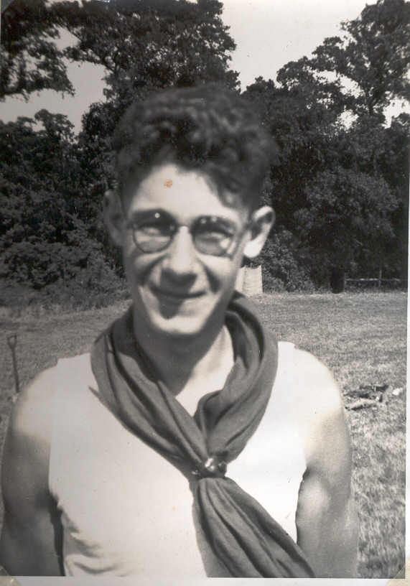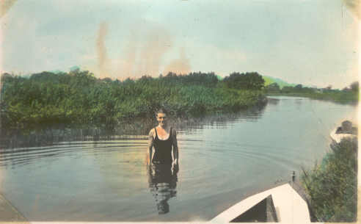
Left – Jack Points
Below – Duke Kidd

1939
We have to report that Billy and Goot have joined HM Forces. Jack Parnell is thinking of giving up Scouting owing to present conditions. On the advice of Mr Boardman and Billy, it was decided that Points should continue to carry on with the help of a new member Leslie Landamore of Wroxham. (Previous a member of Wroxham Cubs and later of 3rd Leigh on Sea Highfield Scout Troop).
Sept 17th. Points and Landamore visited Cromer and other coast places to see what other Sea scouts are doing with Mr Boardman.
Sept 20th We hold our first Scout meeting and boys seem keen to continue.
Sept 24th We hold our first Rover meeting. This day, being Sunday, Shem Duke and Les sailed the latter’s 12’ hak racing dinghy round to the Den. Discussions on Scouting etc.
Sept 30th Saturday. The boys came down and help Les start repairing the Bittern. The bottom was scraped and one plank fixed over one of the bad places. – Points and Landamore spent night down at Den. – Meanwhile Les has made a wind velocity indicator and mended weather vane and indicator.
Sept 31st. Sunday Jack and Les put in another plank on the Bittern. We have been given Eric Stevenson’s two skiffs. Duke came down in the morning and Shem in the afternoon. We broke up the old skiff and plan to do up the outrigger, this we took into the Den. – We did some sailing in the afternoon, wind was very fresh and we had some good fun, nearly capsized.
Oct 2nd Monday. – Rover meeting. Present – Duke, Les and Jack – we did some scraping to the skiff and had a singsong with some jazz band effects.
Oct 4th Scout Meeting – boys had another go at the skiff.
Oct 7th Saturday. We decide to pass the weekend down at the Den. George and Les finished second frame for blacking out the windows of the R. Den. Whilst Points, Jack and Duncan did some night navigation with the skiff – a fire was lit in the Scout Den and we spent a pleasant evening sitting round fire and singing songs etc. – Super bread toast. Jack came down and has decided to give up Scouting. He took away some of his belongings etc.
Oct 8th Sunday. Breakfast at 8.30 am – Bacon, fried tomatoes and mushrooms. During the morning, boys scraped Bittern and later sailing in “Welbor”. Les made a musical instrument out of 3 ply and wire etc and odd bits of wood. Dinner – sausage rissoles, mashed spuds and carrots – stewed apples. Goot and Uniform came down in the afternoon whilst boys did some fishing and Points and Hall went sailing. Tea – Bread jam and cake. Duke came down in the evening plus saw and jews harp (this Les commandeered) and we had a sing song. Finished up with mushrooms bread and cheese.
Oct 11th Wednesday. Scout meeting but only 3 boys turned up. We took opportunity of a fine evening to take Jack Parnell’s tool chest to his house. The rest of the evening was spent teaching boys Turk’s Heads and then a sing song completed things. Duke came down so gave us a tune on his guitar. – Les on Jew’s harp and Points on his uke. – J Parnell came down earlier in the evening and brought balance of Scout Subs.
Oct 16 Monday Rover Meeting. Duke, Les and myself. Les tinkered about with wireless parts. Points and Duke did some target practice
Oct 17 Rover Meeting – Duke Points and LEL
Oct 18 Wednesday Scout Meeting. – Bad weather was responsible for only Collins turning up. We decide on spring cleaning and strip walls of Scout den in view of doing some white washing next weekend. – we had a yarn round fire followed by a cup of hot cocoa.
Saturday Oct 21st. Points came down in evening and after tidying up waited for Landamore to turn up. We slept down at Den.
Sunday Oct 22nd. White frost when we woke up and ice in water in boat outside. In the morning Points whitened the Den helped by Collins. Leslie went sea fishing and brought back 8 dabs which with Duke we fried for tea and supper.
Wednesday Oct 25th. Scout Meeting. – 4 boys turned up – knotting and yarns were the order of the evening followed by yarning and hot cocoa.
Saturday Oct 28 Leslie and 2 Scouts came down in the afternoon and slung skiff and Billie’s canoe on rafters. A quiet evening was spent round the fire in the Rover Den. Leslie overhauled his fishing tackle in view of some pike fishing tomorrow.
Weather has been bad so no boat work has been done for several weeks.
Sunday Duke and Duncan came down – Shem in the afternoon. Points and Les cleaned out lockers in RD – whilst LEL went pike spinning. Points Duncan and Duke made new latrine. After dinner the time was spent fishing and canoeing. In the evening we tidied up and cleared drawers in RD. Spent rest of evening round fire. Les mended “his” chair.
Wednesday Scout Meeting. Knot work – Les Duncan Brewster, Teddy and myself.
Sunday Nov 5 Les, Duke and Duncan turned up in the afternoon.
Wednesday Nov 8 Scout Meeting. – discussed boating navigation etc round fire.
Saturday Nov 11 Spent afternoon on tidying up RD. we decide to spend night down at Den and spend evening playing chess and discussing boating.
Sunday Duke Les and myself spent all the morning scraping combing and decks of Bittern. Les covered up patches and also made outlet for washing basin in Rover Den. In afternoon we varnished combing and put an undercoating on decks. Spent a quiet evening round fire. Shem came down in afternoon.
Monday Nov 13 Points scraped two battens from seating of the Bittern. Duke came down and we spent a very pleasant evening.
Wednesday Nov 15 Finished scraping and sandpapering of seating battens.
Friday Nov 17 Rover Meeting. We spent evening sandpapering and varnishing seating battens.
Saturday In morning Points and Cameron puttied up deck of Bittern and cleaned her out. In afternoon, we brought a dinghy down to Den on trek cart from Landamore’s. We and Les spent rest of afternoon painting decks of Bittern. – A wet night set in developing into a gale towards Sunday morning.
In evening Points made and varnished a new aft hatch for Bittern. Les and Points sleep down at Den.
Sunday Being wet, we decide to spring clean the Rover Den. Duke and Points creosoted the Den in the morning whilst Les tinkered with the wireless set. In afternoon, Shem came down to help in the cleaning. Les made a new shelf over the sink in afternoon whilst Duncan and Points went for a short sail.
Monday Nov 20 Points Duke and Les spent evening down at the Den. We discussed plans for reception of Skipper Churchill and Boardman who are coming to enroll us as Rovers on Sunday afternoon Dec 3rd.
Wednesday Les and Points spent a quiet evening discussing Rover Quest – Vigil – and enrollment ceremony.
Saturday Nov 25 Les, Points and Duncan took Wellbor down to Landamore’s yard – cold damp trip getting home about 5-10. Evening was spent round the fire and games of chess played. Points and Landamore sleep down at the Den.
Sunday. Turning to wet and windy weather nothing more could be done to the Bittern. We spent day tidying up and painting Den in readiness for next Sunday’s enrolement. The lockers were painted white and green and galley and shelves etc painted.
Monday Rover Meeting Les makes a new mantelpiece and decoratives for fireplace – a great improvement noticed. We discuss the enrollment ceremony etc and entertainment of 4th Norwich sea scouts who are spending weekend with us. – We decide on grub etc, costs and programme
Wednesday Nov 29th Les and Points visited the 4th Norwich Head Quarters. We find their Rovers and Sea Scouts very keen to come and visit us. We are initiated into the game of Shin –Hockey. We arrive home about 11.0.
During rest of week all Squires worked hard getting Rover Den ready for weekend. The fireplace and mantelpiece was finished and making final arrangements. – 4 4th Norwich fellows are to sleep the night (Ack - Sho, Tiddler Eddy and Plum) 4 others will come on the Sunday.
Saturday December 2nd Tiddler is the first of our guests to arrive – (3.30) After tea the 3 others arrived. Teddy and Dernk came down and spent the afternoon and evening with us – Duke and Shem came down in the evening – yarning and sing songs. The stew is prepared for Sunday’s dinner (Tiddler peels the onions)
Sunday Up Early – Eddy surprised us by stripping and washing outside in a cold west wind. After breakfast of porridge and bloaters, points took 4 (who came on Saturday) for a row in a skiff. Broad cold and choppy. On our return, 3 others had arrived and with Les, Duke and Shem had cleared out troop Den – games of table tennis followed. Quite a crowd for dinner (Stew and stewed mixed fruit). Just finished washing up when Skipper Coe and Chuckles Killick arrive. We send Senior Sea Scouts on a river hike in the canoes whilst we are enrolled. Mr Churchill and after Mr Boardman arrived. Les, Duke, Shem and Points were then enrolled as Rovers. A slap-up tea followed (tinned fruit, bread, jam and plenty of cake). We are pleased to hear from Skipper that Mr Boardman is to be our new GSL (Capt Cator being abroad on AS). Our senior Guests depart quite early and 4th Norwich fellows going about 5-0. They invite us to their HQ in Norwich.
We are sorry to report that Les has to leave us. – Tomorrow he will report at Uxbridge as he has joined the RAF.
Wednesday Dec 6th A combined meeting was held to discuss the probability of Eric Stevenson of Wroxham, a former member of the Troop, to give us a helping hand. Those present, Hall, points, Kidd (Rovers) and Duncan and teddy Scouts. It was agreed that Points should get in touch with the county commissioner (Skipper Coe) who would write to Mr Stevenson.

Saturday Dec 9th Points and Cameron scraped the small new 8’ dinghy, ran some pitch into some of the seams, gave her bottom a coat of tar varnish and in the afternoon a coat of white obliteration paint. Teddy and Brian Varden (a new member) came down in the afternoon and helped. We were also surprised to see Leslie return but are informed he has to go back on the Tuesday. Points and Les cleaned the stove –pipe with the aid of a weight, some string and a piece of rag. In the evening, Points instructed Duncan and teddy in some boat work and simple navigation work. The rest of a very pleasant evening was spent spinning some creepy yarns (thanks are due to teddy for this). Duncan and Points sleep the night at the HQ.
Sunday. After breakfast of bloaters and bread and marmalade, Points and Duncan put a coat of green paint on the dinghy. Teddy Les and Duke came down in the morning and we all set to work scraping the outrigger skiff. In the afternoon, Points and Duncan took a canoe and fetched two dead alders and towed them to the Den. In the evening, we entertained some visitors (darts etc). Shem and Duke came down and we make arrangements to visit 4th Norwich Troop HQ next Wednesday.
Wednesday 15th Shem, Duke and points cycled to 4th Norwich HQ. A light supper was very much appreciated followed by an epidiescope show (Plum). – Shem and Duke were initiated into that game Shin Hockey (no one hurt).
Sunday Dec 17th Duncan Points and Duke put a coat of green paint on small dinghy and a coat of white obliterating paint on inside.
Wednesday 27th No meeting owing to bad weather (snow and rain). Plan to visit 4th Norwich on Friday next to hear a talk on seamanship.

1940

The new year – We start off by experiencing the worst winter any of us have ever known. Snow and frost held up things throughout January as it was often impossible to get down to Den owing to depth of snow and drifts etc.
Saturday Feb 17th At last we were able to make a start. Several boys seem anxious to make a start and turned up in the morning. We clear up the Den in the morning and during the afternoon started collection of waste paper. This will be stored until collected by the merchants in the stables behind the late Mr Stephen Sutton’s house. During the evening Duncan and Points discussed the Scheme and new recruits. We plan to hold if possible meetings every Saturday afternoon whilst the Scouts will collect paper during the mornings.
Saturday Feb 24th Scout Meeting. – Several new recruits turn up and all seem anxious to join. Will this continue? The Bittern was scraped, games and talk on Scout Law. We welcome new Rover Squire Eric Stevenson (ECS) from Ashmanhaugh. Spent evening with Duncan and Teddy discussing recruits. Dick Bacon visited Den.
Saturday 2nd March Scout Meeting Worked on Bittern. Spent evening with Duncan and Eric. Boat work.- Discussed and planned a canoe hike to Barton Broad the following weekend.
Saturday 9th March At 10.30, Points and Dime set off in Billie’s canoe to Barton Broad. During the trip we visited Miller’s Mill, a Thames Barge “Swale” and a windmill working. We arrived at Cox’s Yard at about 5-30. We hike the 5 miles home.
Sunday 10th Owing to bad weather, Duke did not attempt the “Barton Hop” in his kayak. We came down to the Den and work on Bittern’s sails. In afternoon, Points and Duke explored Barton Broad (the weather cleared) whilst Dime and Eric explored Wroxham Broad in the kayaks.
Monday Points and Eric spent evening down at Den. Scout work.
Tuesday Extraordinary Meeting to discuss Scouting in general. Those present:- Eric Stevenson (senior), Duke, Shem and points. It was decided that Mr Stevenson should become SM and Points ASM. It was proposed that meetings (Scout) should be held on Sat; afternoons and evenings and Rover meetings on Mondays.
Wednesday March 13th Points Dime and Eric spent evening splicing and general Scout work.
Saturday March 16th Finished scraping and sanding of “Bitterns” topsides and applied coat of undercoating. Table tennis and tea. Mr Boardman rolled up about 5 to see Mr Eric Stevenson about Scouting etc. He took numbers and names of boats etc so as to have them all registered. He stayed to tea and kindly provided cherry cake. One side of the sailing dinghy was scraped. During he evening, discussions were of a topical nature and Eric spun a yarn (ghostly type). Rules of road etc as applied to yachts was discussed. Those present Eric Stevenson (junior) his nickname is now Pep. SM Eric Stevenson, Points, Duncan, Teddy (after 5.30) and Sawdust.
Sunday Rain prevented Duke from making the Barton trip. In the morning Duke, Points, Dune and Eric painted inside of small dinghy. During afternoon Duke and Points hiked to Barton and explored the Broad and dykes etc. whilst Eric and Dune went in Kayaks.
Thursday March 21 Leslie comes home on leave – during afternoon an undercoat was put on Bittern’s topsides and we got “Welbor” ready and rigged for trip to Barton on the morrow.
Good Friday With a light breeze Les and Points start for Barton (10-15) arriving at 3.30. Duke starting earlier 9-15 by kayak reaches Barton at 1-30. Eric and Dune use “Snipe” which is already at Barton. We all had tea by camp fire on “Ant Island”.
Saturday Dunk, Les and Points brought home “Welbor” and “Snipe” by trailer.
Sunday. Pleased to welcome Harold Nichols of Sprowston. – He has decided to become a Rover Squire. Les, Harold, Shem and Points sail on Wroxham Broad.
Easter Monday Worked hard on Bittern all day. – Shem, Duke, Harold, Les and Points. The long and messy job of tarring the inside was completed.
Thursday March 28th Harold and Points spent a busy evening clearing out cupboards etc in den
Saturday March 30th Part of inside of Bittern was painted. In the evening the urgent job of building up the quay heading was started.
Sunday In the morning the quay was finished. Harold and Points plan to go sailing – (in “Welbor”).
We sailed out of Wroxham Broad under jib alone and a strong wind was blowing. The reefed mainsail was hoisted and an exciting passage was made to Salhouse Broad where we had lunch. – Here we met Dunc, Eric and Jacko who had arrived in canoes. After lunch we thought we would make the run to Horning and back. As far as Miller’s Mills going was easy. We were running down the Swan Reach with Harold at the helm. The wind had picked up stronger and a sudden jibe capsized us. We had an early swim to the bank and after swimming a dyke found a row-boat to try to recover some of our belongings which were then floating downstream. With some help, we got the boat to the “Swan” where we had a hot bath and clothes. After putting boat in water again we got a tow home, none the worse for our mishap only losing 2 pairs of shoes and a sail bag and our tea.
Monday April 1st Rover Meeting – General meeting finishing with a game of table tennis.
Thursday Harold fetched his kayak and brought it round to the Den. We lay out carpet, a gift from Mrs Kerison. Although a bit holey, it gives the Den a more homely touch.
Saturday April 6th Scout Meeting. – The inside of Bittern was painted. The old Dutch Boat was righted and the gear for it found. We hope to use this as a land ship for instructional purposes – especially for those who cannot yet swim. The evening was spent in practicing morse
Sunday In the afternoon, Shem Duke, Points and Harold continued working on “Bittern”. During the evening Points and Harold fetched a dinghy from Landamore’s Dyke.
Monday April 9th The Rover Crew entertained 2 Soldier rovers who are stationed in the village. A very pleasant evening was spent over mugs of coffee and biscuits. Table tennis games for all were arranged. We hope to see more of our friends in the future.
Saturday April 13th Started canvassing port deck of the “Bittern”. The centre plate was also taken out of its box and the rust chipped off and given a coat of tar varnish. – Scout spent a pleasant evening playing soe-rugger and creeping in at dusk.
Sunday Painted decks and hull (final coat) of Bittern
Monday 15th April Rover meeting. – General discussions and morse practice.
Saturday 20th April Started on the extension plan for building up a quay heading. The water line was put on Bittern.
Sunday All Rovers and Scouts worked hard and finished the new quay heading. Eric put stern band and rudder keel plate on “Bittern”. We launched the Bittern. We are pleased with our work and the old girl loos as smart as ever she was. Stepped mast and rigged standing gear in evening.
Monday Rover meeting. – Rigged up a jib on Bittern and went for a short sail.
Saturday 27th Boys went canoeing. Rovers went for a sail in the Bittern on Wroxham Broad in the evening.
Sunday Boys under Eric (Pep) went canoeing all day whilst Rovers and 2 soldier Scouts went sailing.
Monday We have to report that Duke has left us to join the Navy. We wish him all the best and a speedy return. He is doing his training at Skegness.
Rover meeting – all Rovers and squires present. Mac (Soldier Scout stationed at Wroxham) gave us some good morse practice.
Thursday May 2nd Points with 3 of the Scouts cleaned out the main Den as it make it presentable when Mr Churchill and Boardman visit us next Saturday.
Friday Points, Harold, Duncan and Pep went sailing on Wroxham Broad in the evening.
Saturday. Mr Boardman (GSM) and Mr Churchill (DC) visited us. Eric (Pep) and Harold were invested. The coming whitsun camp was discussed. This (sea Scout camp only) is to be held at Hickling. – It is hoped to have 2 half-deckers and to get shown round by Mr Jim Vincent. – Points, Pep, Teddy and Duncan decide to go. Boys took part in morse outdoor game on river.

MEMBERS AND EX-MEMBERS OF THE GROUP WHO ARE NOW SERVING IN HM FORCES

NAVY MERCHANT NAVY
Douglas Read (Chunky) Kenneth Wade (Fish)
Arthur Read (Arto)
Geoff Girdlestone
Maurice Ward (Tubby)
Gerald Kidd (Duke)
Com Sam Brooks (Rajah) Late GSM
Sam Brooks jun
Joe Brooks RAF
Arthur Symonds
ARMY Leslie Landamore
Billy Curson RASC late SM J Braybrooks (Tadpole) Late SM
Edwin Gotts RE (Goot) Basil Clinton (Smiler)
Arthur Parnell RA (Led) Murry Hansworth

An ending and a new beginning

The 1st Wroxham Group continued to meet until 1948 and then the Group closed down. The reasons for the closure are not clear, but was probably due to a lack of support at the time. The HQ building in Caen Meadow was sold for £80.00 and the money lodged with Scout HQ for safe keeping.
Shirley Ebdell moved to Hoveton in 1949 and when her son Martin was 8 in 1966, she tried to find a place for him in a Cub Pack, but none was available. Barbara Bennett suggested that Shirley became a leader and started a Cub Pack to fill the gap. Shirley agreed to do this and so she became Akela and subsequently in 1968, her husband John Ebdell became Assistant Scout Leader with Graham Noble as GSL. The Group adopted the new name of 1st Hoveton and Wroxham partly because the meetings were held in Hoveton and partly because adding Wroxham to the name enabled the new Group to show continuity with the 1st Wroxham and thus claim the money from the sale of the Caen Meadow HQ. A committee was formed and the early meetings were held in the Vicarage garage in Horning Road Hoveton.
There were 8 Cubs in the pack when it started, and the founders included Martin Ebdell, Roddy Gainsford, Felix Smith, Timothy Appleton, and Gordon Hughes (who’s brother Barry joined 6 months later). Numbers grew rapidly and peaked at 48 Cubs who had to be split into 2 groups meeting on separate nights.
Despite the gap from 1948 to 1966, the new Group can trace its ancestry back to the foundation of the 1st Wroxham in 1910.

Re-starting the Group 1966
This history was written by Peter Fox and sent to the Group for the 25 anniversary event.

Shortly after. we moved to Hoveton in May 1966, we found that Mrs Shirley Ebdell was the Akela of the local cubs which our son Keith joined. John was too old as were several other lads who wished to join the Scouts so while the Cubs continued meeting at either the garage at the St. John's Vicarage or later at Hoveton Secondary Modern School (as it was then known) several of us dads got in touch with the leaders of the 35th Mousehold Troop in Norwich, and 5 lads joined there. They were: John Fox, William Ling, Vernon Bane, Gavin Henderson and Gordon Hughes. The dads used to take it in turns to run them up and they were made very welcome and commenced their Scouting there.
Then a Scout Committee was formed at the request of Mrs Ebdell and I think we met mostly at the Village Hall or at Norfolk Fruitgrowers. I think the Chairman was a Mr Henderson, Gavin's father. A Mr Grimmer, father of Mark Grimmer, was treasurer. Also on the committee was a Mr Smith, husband of Mrs Katherine Smith, and father of Felix Smith. Alfred Ling, of Hoveton, father of William Ling, was also a member as was Bertie Bane father of Vernon Bane. A Mr Bill Verrells joined the committee later. Then there was me…. I believe at that time, the funds were extremely small, consisting of a sum of money held by Scout H.Q. from the sale of the original Scout Hut on Cain Meadow, Wroxham.
The first suggestions put forward were to form a new Scout Group under its present title. Then there were suggestions as to what form the new Scout Hut was to take. After much discussion it was agreed that the size would of necessity be small and I arranged the purchase of a prefab from a scrap merchant I knew at Stoke Ferry, a Mr Geoff Allen. It was to cost less than £200 I think.. After much discussion Mr Henderson persuaded the Village Hall Committee to let us build it on village hall grounds on the understanding that it reverted to the Village Hall when no longer used. Somebody borrowed a JCB and dug out the footings sufficient1y deep enough for a five storey block so we had to fill part of them in again. Eventually it fell to Bill Verrells and I to get the base down and this was quite a job. We ordered readicrete. It came in a rush and we were nearly buried in the foundations… The hut arrived, was erected and we then replaced every pane of glass which of course had been smashed. We finally painted it out and it looked very trim. The original chimney hole in the roof had to be filled in so I eventually had to use an old aluminium saucepan to jam over the top. Eastern Electricity laid on the mains free of charge and a local lad wired it out very cheaply. Everybody was very good to us.
During this time the Scouts and Cubs had been making very good progress. All we were short of were rowing and sailing craft. Mr Tom Blofield gave us permission to use an old boathouse on his estate. Mr Graham Noble had become Group Scout Leader and John Ebdell also joined us.
Names of scouts I can recall in addition to those previously mentioned are:
Robin Rivett, Wroxham.
Michael Sandall, Tunstead.
Ian .Fazakerly, Rackheath
Adrian Oakley, Hoveton.
Felix Smith, Belaugh.
Barry Hughes, Hoveton.
Gordon Hughes, Hoveton. (Unfortunately killed in road accident}
Fund raising of course was the committee's main aim and in this respect we ran jumble sales, a sponsored silent sit-in at the St. John's hut and Graham Noble organised target changing at Sennowe Park during rifle shooting competitions, which raised funds. My own particular effort was running discos at Hoveton .Village Hall. We certainly packed them in -I think everyone from Hoveton Secondary Mod. used to come -sometimes 200-250 at 2/6d a time. Great styles too. Coke by the crate and crisps by the carton. Some RAF lads -The Allnighters, used to provide the music at £8.00 a night. Then the Performing Rights Society got to hear about us and: they tried to muscle in. We certainly raised some funds.
The Group had its Standard which was paraded on St. Georges Day at Aylsham, Stalham, Norwich, etc. Camps were attended at Sennowe Park and Orford Ness, and the Scout Jamboree at Sennowe Park. The Scouts joined with the British Legion on floats at the Hoveton Carnival.

The First Scout Meetings of the newly re-formed 1st Hoveton and Wroxham

These notes were written by the late Graham Noble, Former Scoutmaster. They give fascinating details of what happened at the first Scout meetings when the 1st Hoveton and Wroxham Sea Scouts re-formed. Thanks to his son, Nobby Noble, for giving permission for their use.

1st HOVETON AND WROXHAM SCOUT GROUP

6th February 1968

1st meeting of the newly formed troop, the meeting started at 17.00 hrs with prayers taken by the vicar the Rev.P.Nicholson.The meeting proceeded with basic movements of hand signal drill. Falling in facing the palms of the hand, and sizing falling in, in relay formation. This was followed by games, a talk by myself (GSL. Graham Noble), some knotting with Mr.J.Ebdell. We had several visitors, Jeff Crane ADC Sea Scouts, Dick Smithson ADC Broadlands, and the Norwich Mercury photographer. Twenty four boys turned up at the meeting, enough to make three patrols, among the boys were a number of Sea Scouts ex 35th Norwich who live in Wroxham area. Two scouts already Scout Standard PLs)
The meeting closed at 21.00 hrs. Also among the Scouts at the meeting were two Scouts from the 1st North Walsham.

Extract from Norwich Mercury

SEA SCOUTS REVIVED
The 1st Hoveton and Wroxham Sea Scout Group was revived at a gathering attended by 24 boys at Hoveton Secondary Modern School on Tuesday evening. With them are Flight Sgt. Graham Noble from RAF Coltishall (extreme right) the new Group Scout Leader and Mr. John Ebdell, his assistant.

13th February l968

Second meeting started with prayers by the vicar, the meeting then continued with a few sign drill movements, followed by a game of Hare and Hound. I then handed over to Mr J. Ebdell to instruct in knotting and whipping (sail makers).
During the period whilst Mr. Ebdell was running the meeting I selected three patrol leaders, John Fox, Gavin Henderson and Robin Noble. The patrol leaders selected the following patrol names, Owls, Foxes, Woodpeckers, and were allocated as follows: John Fox PL Foxes, Gavin Henderson PL Owls, Robin Noble PL Woodpeckers. Appointments are on three months probation. Patrol leaders were instructed to look at their Patrols with a view to submitting an assistant. Boys were sorted out to the three patrols.

20th February 1968

Third meeting started with prayers taken by Skip, a few minutes fall in drill, forming up in threes from the tallest on the right shortest on the left hand sign, no further instruction to be given, after a couple of practices it went very well. Will need to do more practice before St. George’s Day.
Game's Blind Pirate, Back to Back Ankle Grabbing and British Bulldogs. The last game seems a great favourite although I am not very fond of it.
Troop divided for patrol corners, when instruction was given by Patrol Leaders in First Aid, Rescue, Mapping and Pioneering in readiness for Wayfinder hike on Sunday 26th.
Mr. J. Ebdell and myself showed the boys some rescue knots, man harness, fireman’s chair and alpine butterfly.
Evening closed with prayers by Skip.
Everyone asked to bring a beanbag next week.

24/25th February 1968

Ordered Troop colours in the hope of getting them by St. Georges Day. Spent most of the day laying out hike for the troop tomorrow
Troop assembled outside the school gates at 09.55, Patrols were given a briefing and a card containing instructions where to find next clue. First patrol Foxes away at 10.00 other patrols left at 15-minute intervals, Owls then Woodpeckers.
The destination was Grange Farm (by kind permission) and first patrol (Woodpeckers) arrived at 12.30 closely followed by Foxes. This posed a problem, as the Owls were missing having not been seen by the other two patrols. After much searching by Skip and Mr. King, Owl patrol sighted by Skip looking for the last clue. Gavin explained the delay, slight misunderstanding of second clue. Mr. & Mrs. King supplied the boys with a hot cup of soup, which was very much appreciated, as the day was rather keen but dry and bright.
After lunch projects began, patrols had to get over a stream with all equipment including bridging equipment. This was rather interesting and showed that we need a lot of training.
Carrying a person on a stretcher also had its moments. If more assistants had been available then we could have done more activities, but as it was I was dashing from one activity to another.
I forgot to mention earlier that the turnout was very good, out of 22 boys 19 were present.

Points were awarded as follows:

 | OWLS | FOXES | WOODPECKERS
TURNOUT | 9 | 9 | 9
FINISH | 5 | 7 | 8
WOODCRAFT SIGNS | 1 | 2 | 2
PREPAREDNESS | 5 | 7 | 6
FIRST AID | 4 | 7 | 6
BRIDGE | 2 | 7 | 6
TOTALS | 26 | 39 | 37

Possible points 59

Foxes were the winners and will represent the troop on the 24th March in the Wayfinder Competition.
After a few words the boys started hiking for home, Hoveton School and ended at 16:00 hrs all tired and quite happy.

27th February 1968

Fourth meeting started with prayers by skip, the results of Sunday’s hike were given out Foxes. 39, Woodpeckers. 37, Owls. 26. Fall in and drill practice foe St George’s Day Parade, boys doing fairly well but more practice needed. Games chalk rugger played with beanbag, only two boys brought beanbags this week. Played a tape of the movement for the beginners whilst Mr. Ebdell instructed those enrolled in parts of the scout standard. I had patrol leaders together for a sort of PL council, hoping to get PL & APL to run this themselves shortly. Master map game and a short session of British Bulldogs, the meeting closed with prayers.

5th March 1968

Mr. Ebdell started fifth meeting in my absence. I arrived at approximately 8pm. The meeting had been conducted on the usual pattern, very successfully. Subs were collected for the first time, 4/- per head. Letters given out for parents with regards to parents meeting and the requirements for the weekend of 16/l7th 8March when the boys are target running for the Norfolk Rifle Association at the annual indoor meeting in the Aylsham Road, Norwich. Bill Dady joined the troop and was put into the Woodpecker patrol. Results of master map game given.

12th March 1968

Sixth meeting starting with prayers, and then on to basic drills included a little marching. Some of what they had been taught had also been forgotten but progress was made. The marching was done outside in the playground.
One new member joined tonight, Peter Bully of Horstead; he was placed with the Owl patrol, as they are the smallest in numbers and stature.
Mr. Ebdell ran most of the games whilst I attempted to get the records up to date, completed Fox patrol and started Owls. Boys briefed on requirements for Saturday and Sunday.

Weekend 16/17th March 1968

The boys did a good job at the Norfolk Rifle Association, changing targets. On Saturday 15 boys were present and 17 boys on Sunday, for which we received £24/-/- for troop funds. The boys were given 2/6 each day from the funds, total of £4/-/- expenses which left a net profit of £20.

19th March l968

Seventh meeting usual start. Basic drills of falling in and marching, the boys were not as good as usual and a little more practice was needed. Games included wheelbarrow Race, Jehosophat, Blind Mans Sanctuary.
During corners the Peckers erected a hike tent, using chairs to hold up the guy lines and tent lines. This was a very good effort and worthy of note by other PLs
Progressed with completing the record cards but still have some more to do. Congratulated the boys on their turn out and told them the results of their labours.

26th March 1968

John Ebdell ran the meeting in my absence. The meeting was run to the now standard pattern. Parade drill and marching followed by games and then corners. A new recruit was brought along.

2nd April 1968

The meeting started with prayers and notices; there was another new recruit. The parade drill was rather rough and had to be done several times before they got it right. I was on my own tonight as John was working, collected subs, quite a number had forgotten to bring them, reminded those who did not bring subs this week to bring subs next week. Ran through Wayfinder competition subjects ready for Sunday 7th. Informed all the lads that next meeting would be held at the Vicarage.

7th April 1968

Palm Sunday. Difficulty in maintaining complete patrol due to choir. Finally managed to get patrol of seven to Buxton. The patrol was the Foxes led by PL John Fox. The boys put up a very good show, but lacked experience, and finished 4th out of six. But they all enjoyed the outing. The winning troop was Hainford with North Walsham second.

9th April 1968

The meeting was held at the Vicarage in the paddock. The meeting opened with prayers, a short spell of parade drill, after the drill the boys were sent to collect wood for fire lighting. Whilst the wood was being collected the PLs went through flag drill, with the flag pole only, hope the flag arrives in time for St. Georges Day. Each boy had to light a fire, after this all the fires were put into one. The last game was attacking the flag; the Foxes flag being the only one present was used as the trophy. The evening finished with a campfire and prayers.

16th April 1968

Scouts at the vicarage, wet night and eighteen boys were present. I was considering cancelling the meeting and sending the boys home, but they all wished to stay and work things out in the large garage belonging to the vicar. The meeting started with prayers, games, tug-o-war, patrol corners for only fifteen minutes. Awarded Paul Elliot his Scout Standard badge. Final practice for St. George’s Day parade, troop flag has arrived and is now assembled. Handed to John Fox for St. George’s Day rehearsal at Aylsham on Saturday 20th.

21st April 1968

Sunday 21st St. George’s Day parade, impossible achieved 22 scouts on parade and 27 cubs, total for the group being 49. Both sections had the new standards flying; J. Fox carried scout flag with R. Noble and G. Henderson as escorts all PLs.
Scouts have had a Sicilian dinghy given them and the promise of the use of the boathouse at Blofield estate.

23rd April 1968

I was absent from troop meeting due to duty, John Ebdell ran the meeting in my absence. It is a good job I have a reliable helper like him. Bob-a-job money collected, total from group over £44.00.
27th April 1968

Saturday 27th, John, Bob Badger, and myself who is just about to join us, all went out on the launch S63 E WINDRUSH. The trip, which was to try the boat out for scout use, was successful but not uneventful, for the engine packed up on us at least five times. Three gallons of petrol were put in at a cost of 18/-.
Our thanks to Mr. Dady for his offer of the use of the boat by the scouts.

30th April 1968

The meeting was the orthodox type, names were taken of those boys who wished to go to the Jamboree at Sennowe Park 3rd to 10th of August. Six boys indicated their wish to go and two others said they would let me know during the week. Hand signal drills were practised for a few minutes and was followed by game of Hare & Hounds conducted by John Ebdell whilst I prepared a modified version of Kim’s game, corners followed, which with some testing ran on until it was time for prayers and finish.
Geoffrey Parker was absent, John Ebdell was rather worried about this, as a number of boys said he had left, further investigation proved that he intended leaving, he is being encouraged to come back.

7th May 1968

Tonight's meeting was an outdoor activity. Three map references were given on an OSl26 map; the references represented the letters B H R.
Once the patrols had identified the letters, they were despatched to Wroxham to find out all about it. The Woodpeckers were the first with the best answer, the second back were the Owls, their answer was fairly good but they did not return as a patrol. The Foxes were last back as a patrol with a poor answer, but beat the Owls because they arrived as a patrol. All patrols were back before time.
The evening finished with Bulldog in which two scouts showed very bad sportsmanship by fighting (Paul Elliot and Andrew White). The football team was sorted out and it was decided to play the match on the 17th May at Stalham.
All boys wishing to go to the Jamboree have now paid up, total eight.

14th May 1968

The troop meeting was based on testing and instruction. Bob and John ran a game of thread and needle, then we went to test and instruction. Five boys gained the Scout badge, Vernon Bane, Geoffrey King, David Reekie, William Ling and Alan Noble were all enrolled, Alan also received his Link badge. The troop flag was used for the ceremony; Bob and John ran blind pirates while I prepared the enrolments.
Sent letters to parents with information about Sennowe Park 25/26th May for shooting meeting. Football match arranged for 17th May at Stalham.
Met Mr. Williamson a commissioner from Cheshire called to see us to ask about hotel accommodation, he saw the scouts and came to see if we knew of anywhere suitable. He also knew the 6th Barry and is getting me the address of the GSL.

21st May 1968

The meeting was run entirely by the patrol leaders, the games and a short session of corners, prayers and closure were all done by the PLs. The only thing I was asked to assist in was one of the games. I also gave out the notices at the end of the evening. During the evening I had to leave Bob and the PLs to get on with it. In order to try and find a substitute for the forester which John only let me know about the night before when I had asked him if it was laid on for the 28th, I had no luck in finding the substitute.

28th May 1968

The weather was good so one patrol (Woodpeckers) was sent out to lay a trail and hide an object in the vicarage paddock. The route was a fairly good one although one or two of the signs were rather obscure, natural materials had been made use of in nearly all signs.
During the event two scouts Keith Hardy and Robin Rivett witnessed a road accident on the Tunstead Road.
The game finished at the vicarage without the attacking patrols finding the hidden treasure.

4th June 1968

Down at the vicarage, first we went for a stroll down to the boathouse; it was the first time the boys had seen the place. It is on the land opposite the vicarage owned by Mr. Blofield. On returning to the vicarage Bob had prepared a simple form of orienteering, which was quite good but not too successful with the boys, something rather new for which they were not really prepared, but we shall try it again after a bit of training. The evening finished with prayers behind the vicarage; the vicar paid us a visit

GSL’s Report 1986

By Tony Davey

When I joined Hoveton & Wroxham in 1975, as assistant Scout Leader, the troop consisted of 24 Cubs and about 19 Scouts. This went up and down from summer to winter. At this time, the only water-born craft were 4 canoes, two of which were not usable. Since then the troop has gone from strength to strength building up in numbers to about 40 and with the cubs still at around 24. We have also built up a fleet of boats:- 6 canoes, 14' rowing boat, rubber inflatable, 2 Hobart sailing yachts, Enterprise sailing yacht, 11' Rescue boat with 35 h.p. engine, also 2 outboard engines. Oyster sailing yacht with work not completed. Also about 8 canoes which belong to some boys and 4 sailing yachts which can be used by the troop.
To keep a troop of this size afloat we have a group council committee and chairman. Over the past few years we have been very lucky in having good chairmen in Ray England, Ray Lewis and at the moment we are very fortunate to have Barrie Mortimer and an exceptional committee, who, over the past 6 years have raised enough money for us to keep the troop afloat and also build a new H.Q. In this time the boys have been helping fund raising and working on the new building.
In 1986, the boys excelled by winning:- District 6 a side Football, District Swimming Gala, District Wayfinder camping competition, County Wayfinder camping competition, 9th in Border hike, the highest in the county, and 9th in the night exercise, and the cubs tied for first place in the cub sports.
We also try to get the boys away every year to summer camp. Some of the places we have visited over the past few years are:- Northey Island, Essex; Loch Earn, Scotland; Aldburgh; Ipswich; Walesby Forest, Nottinghamshire; Blakeney.
In 1985, Hoveton & Wroxham started its own Venture Unit of 8 boys and 2 girls. As Group Scout Leader, I hope this unit will continue to grow. One of the Venture events this last year was a triathlon, hiking from Thetford along Peddars Way to Hunstanton, then cycling along the coast to Hickling, then rowing back to Wroxham
When I joined as assistant leader in 1975, two scouts were working up through Scouting to Patrol Leaders. As I went on to become Scout Leader, these scouts stayed on and helped with the troop, then continuing on, one to be Scout Leader and the other as assistant Scout Leader, then to Venture Leader -Julian Morley and Eric Clark.
Auntie Babs (Barbara Howard-Smith) carries on as Akela with the Cubs. She was with the group before I joined, approximately 14 years service. Also Fred (Crane), the eager beaver, who is Assistant Leader to Julian and joined in 1982.
We have a good team but could do with some more help.

A home of our own ....
The HQ building in Hoveton was really too small for the Group's needs and there was a time when meetings were actually held in several garages scattered round the village and connected by CB radio. This was an unsatisfactory arrangement, and following an arson attack while the Group was away at camp it was decided that a new HQ had to be found. Building your own HQ is no small undertaking and it involves a lot of investment of time and effort, not to mention a huge fund raising operation. However, under the guidance of GSL Tony Davey and Chairman Barrie Mortimer, the Group pulled together and in 1988, the 1st Hoveton and Wroxham moved again, this time to its new purpose built HQ in Nobel Crescent Wroxham.
That is where we still meet.

THE NEW HEADQUARTERS

From the 1987 Group Magazine. – by Fred Crane

After its membership, a groups most valuable asset is its Headquarters, being a place for learning new skills, meeting friends, having fun, sharing prayers, enjoying comradeship, taking part in challenges, building characters, etc. A Scout Headquarters has to be capable of providing the means for all these activities, perhaps several times each week. Any shortcomings in the adequacy of the H.Q. will undoubtedly reflect the overall aims of the Scout movement being that much more difficult to attain.
And so it was that in 1981 the then executive Scout committee made up of Barrie Mortimer, Richard Cox, Mike Clements, David Parr, Ray Lewis, John Hardy, Norma James, Lindsey Sidell, D. Foreman and Leaders, faced with continuing repair bills decided to set up a headquarters fund. The Scout H.Q. at this time, being sited on the Hoveton Village Playing Field and being constructed of asbestos panels, had suffered from the vagaries of time and at thehand of vandals, e.g. broken windows and exterior panels. It had proved necessary to rebuild a complete end of the building and repair various panels elsewhere and the roof continually suffered from leaks. It was plainly obvious that group funds were going to be continuously needed simply to keep the headquarters weatherproof. Any thoughts to improve the facilities by means of heating, toilets, etc. were constantly dogged by fears that money spent in this way may well be wasted and should perhaps be utilised in improving the overall fabric of the building. The decision therefore to set up a building fund and concentrate on fund raising efforts towards obtaining a replacement headquarters was almost inevitable.
A new committee under the chairmanship of Barrie Mortimer and made up of Richard Cox, John Hardy, Mike Clements, Ronnie Dack, Fred Crane, Lindsey Sidell, Liz Leach, David Parr, Jane Kidd and Angela Webster set up a Scout Hut Appeal Fund with a target of £5000, and because of requirements of the Village Hall .committee that any building erected would have to be sectionally constructed and capable of removal, plans were made to obtain various quotes regarding different types of sectional buildings. In the meantime, various suggestions of assistance were received such as financial help with repairs to the old H.Q. by the Rotary Club and the offer of a tin church. The committee, however, decided in favour of their original aim of replacing the existing H.Q. with an improved construction.
The group finances had stood in March '80 at £513 and by March '81 this had risen to £920, but to increase funds substantially over and above the normal running costs of the group it would be necessary to introduce more frequent and effective fund raising events.
By the Annual General Meeting in March '83, as a result of the Scout troop expanding to 30+ boys, it became obvious that alternative improved accommodation was urgently necessary.
With group funds at £3050, we were not yet in a position to purchase the required size of sectional building and as a temporary measure, the troop was housed at Wroxham First School which had become vacant. The Cub pack continued to use the old H.Q. This new accommodation, although ideally suited to our needs, could only be regarded as a temporary measure, since plans were in being for its demolition in July '84 to make way for housing development. An alternative plan to utilise a building within the grounds of Broadland High School was thwarted
when permission was refused. This breathing space of some 15 months was seized by the committee to accelerate their fund raising efforts.
In the Autumn '83, matters came to a head. The cost of the building that had so far been envisaged had escalated to a figure in the region of £13,000. At the same time, the Village Hall committee had indicated that our present site would not now be available to us, had offered a site adjacent to the Village Hall itself and had requested an early vacation of our current site. At this time, also, Mr. Trafford offered a piece of land for rent or purchase in Nobel Crescent, Wroxham.
The committee, after many hours of thoughts, discussions and arguments over the course of several meetings and many months finally decided to take the option of purchasing the land on the Nobel Crescent site and thereby for the first time enabling the group to own its own site and construct a permanent brick built Headquarters some 60' x 30' in size.
With now a definite target and plan to aim for, our fund raising activities were gathering momentum. Under the expert management of our chairman, a vigorous programme of Car Boot Sales, Jumble Sales, 50/50 Auctions and, later Flea markets was drawn up. These activities were further enhanced by the introduction of a caravan given to us by the local Lions Club from which hot dogs and drinks were sold.
By March 1985, after a hectic year, our fund raising activities had developed into a well trained and organised team effort with each member of the committee and leaders carrying out a specific function thereby gaining us a reputation for providing a most efficient service.
Whilst it would normally be wrong to name specific parties, in these circumstances it would be wrong not to name the members of the committee and others at that time who gave so much of their time and energies, often in very inclement weather conditions.
The following is a list of the names and activities in relation to fund raising events:

Barrie Mortimer advertising, sign erecting, co-ordinating, car parking
Richard Cox finances, tombola, food and drinks, car parking.
David Pye flags, car parking, raffle ticket selling
Roger Clare car parking, sign erecting
Gordon Wigg poster making, caravan
Mike Clements caravan
Rosemary Pye, Gladys Clare,
Christine Cox, Linda Davey,
Dru Crane caravan, refreshments
Brian:Gadd car parking, doorman.

Everyone also helped as necessary at Jumble Sales. The leaders and a small band of Ventures and Scouts helped as necessary, mainly with car park duties. The results of these efforts were reflected in the Group balance sheet as at
March '85 showing £4,800 had been raised in the year; a magnificent achievement which even after group running expenses increased our overall bank balance to £6,900.
Fund raising activities on ever increasing rates was planned for the coming year and in the year to March '86 we had accomplished an absolutely fantastic feat of raising an additional £8,100 towards funds.
In the meantime, following planning permission, in June '85 the site of the new 60' x 30' headquarters in Nobel Crescent was formally laid out and the footings were subsequently dug. As the months progressed we saw concrete laid in the footings, cement blocks delivered, laid out and constructed to complete the footings. This was followed by an estimated 120 tons of various sorts of hogging and many hours of wheel barrowing by boys, committee and leaders alike, before the base was finally covered with 18" concrete at the beginning of October.

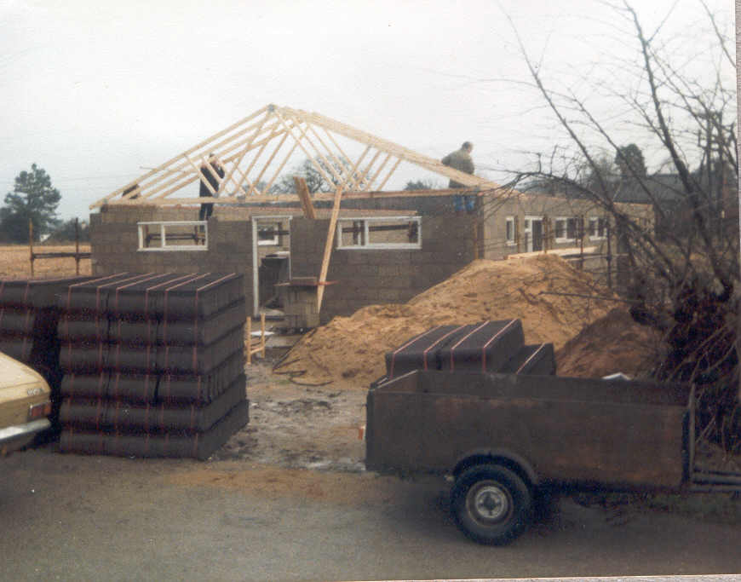
A further supply of concrete blocks delivered then re-sited by the boys paved the way for the professional builders to commence operations and by good fortune with the weather, we were in a position to erect the roof by January '86. It was decided that we would do this job ourselves and with the aid of the professional help of Adrian Leach, roof trusses were erected and secured. Following the building of the gable ends by the builders, we continued our operation by laying roofing felt and 4000 tiles -a co-ordinated operation involving most of the committee, leaders and boys.
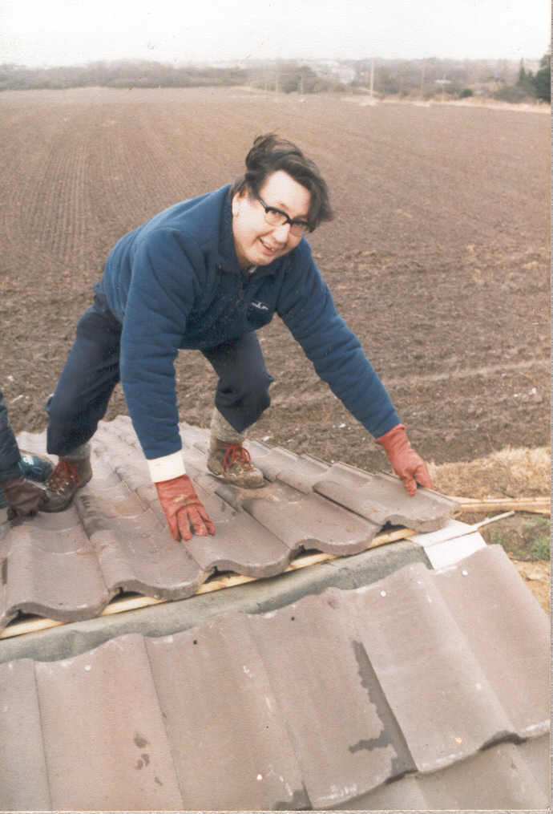
Fred Crane on the roof

During the spring, work was carried out to weatherproof the structure by fixing doors, windows and guttering. Following a further delivery of blocks which were again sited by the boys, the builders completed the internal walls at the end of March. We now had a building upon which we could work without being effected by the weather and during the course of the remainder of 1986 activities such as floor screeding, painting windows and internal walls, shelving for storage, electrics, ceiling boards, etc. were undertaken.
Weather permitting, outside drains, and soak away were constructed, water, gas and electricity supplies laid on and foundations for part of the car park laid.
Following the summer break, and various further acts of vandalism, it was felt that we could no longer use our old H.Q. for weekly meetings and with effect from September 1986, Cubs occupied the new H.Q. at Nobel Crescent with the .Scouts and Ventures following in October at the end of the boating season.
The decision to do this was made all the more final by an arson attack at the old H.Q. which rendered it uninhabitable and perhaps unsafe. Fortunately, our equipment had already been stored in the new H.Q. following Summer Camp, and, apart for some valuable photographs and cub equipment, the group as a whole suffered remarkably little loss:
Increasing difficulties were experienced with trying to operate active meetings at the same time as carrying out the various essential work required to complete the H.Q. and it was decided to enable this work to be carried out more efficiently and without hindrance, to suspend all Scouting activities within the building during the month of January '87.
A concentrated effort was made by all concerned and operations to complete the ceiling, lag the loft, plumbing, floor tiling in kitchen and toilets, etc. were carried out. Severe weather conditions however, meant that this operation had to be extended into February when the laying of the wooden floor would signify the finale to this mammoth operation.
Again to ensure that the sincerest gratitude and thanks is bestowed by the group it is necessary to mention the following without whose dedication and untiring efforts this whole project would not have been possible. Barrie Mortimer, David Pye, Mike Clements, Roger Clare and Richard Cox.
We hope it will be understood that to name everyone who have helped with this project would simply be unwieldy. This does not mean that we are not sincerely grateful to each and everyone who have helped in-,any way. We thank you all.
In the past few years, the group has gone from strength to strength, has increased its membership, extended equipment, formed a Venture unit and now has its very own fine H.Q. These advancements are all the more rewarding because we have achieved them by our own efforts. The funds raised to build the H.Q. which to date has reached a cost of £17,660, have been acquired without assistance of grants from various sources usually associated with such projects. Well done everyone and long live the 1st Hoveton and Wroxham Sea Scout Group.

Memories from Malcolm McKee.

I joined 1st H+W when we were still in the old scout hut in Hoveton and many of the weekends in my first year were spent in the new scout hut digging, painting etc. The final colours of the inside walls we got by just mixing together pots of paint that people brought along on Saturdays. As I remember, the main hall ended up a light green colour and the offices pink.

I joined the Curlew patrol under Chris Crane. I ended up leading the Curlews and eventually becoming Senior Patrol Leader.

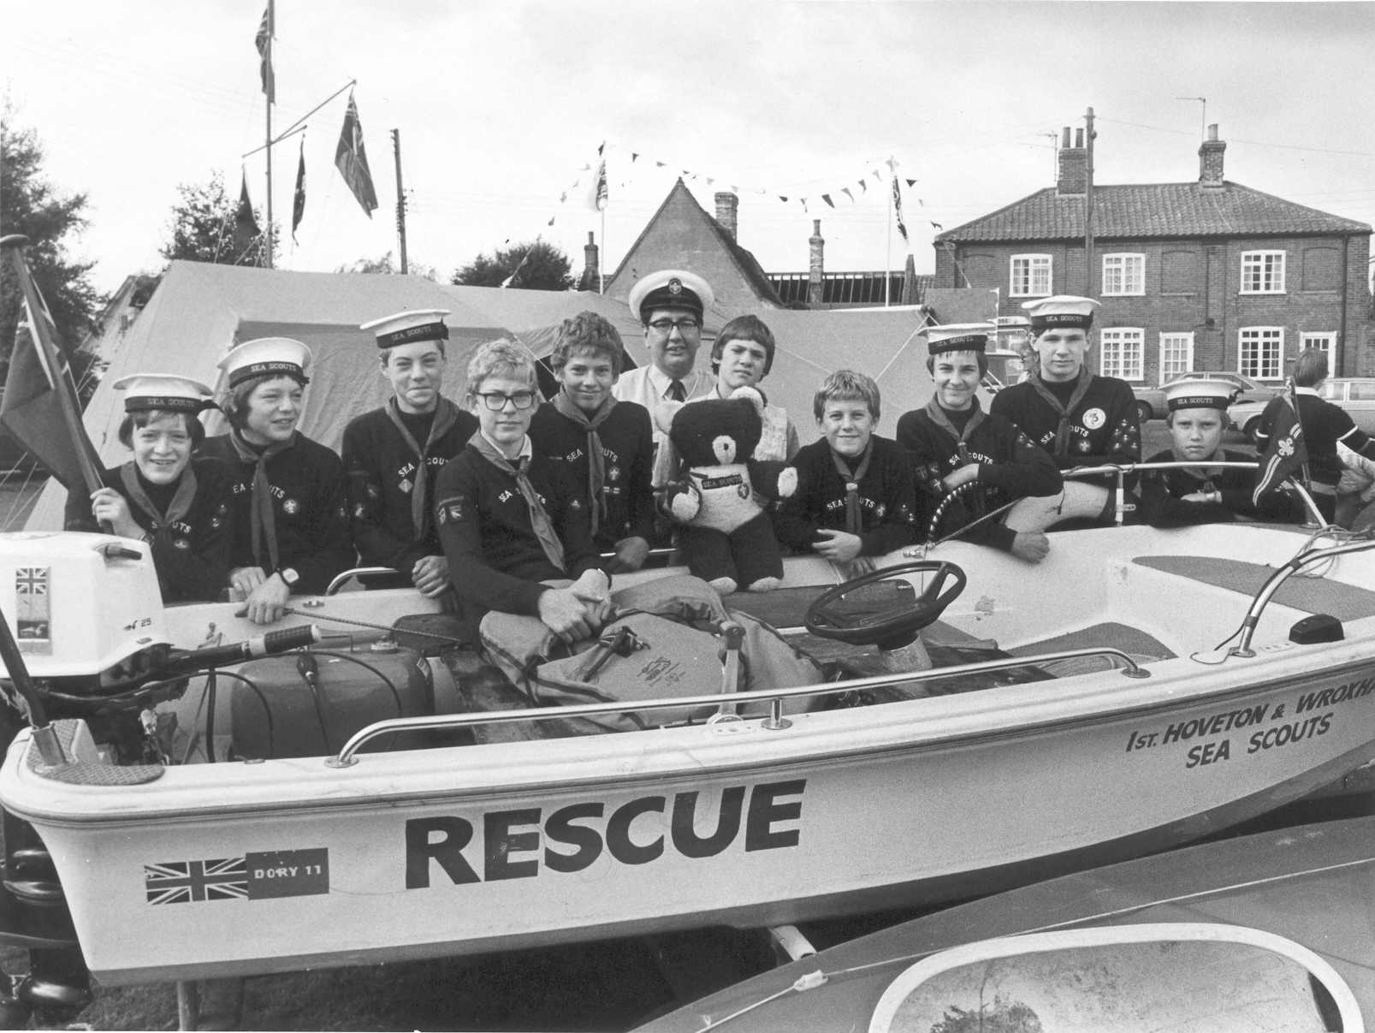

What does a Scout Group do?
A Scout Group is a busy organisation. There are often 3 or 4 meetings a week plus weekend events, hikes, camps and other special activities. The following report is an example of what the 1st Hoveton and Wroxham did in 1986.

SCOUT SECTION REPORT 1986
From the 1987 Group Magazine. Written by Fred Crane

1986 proved to be a most successful and probably unique year for the Scout Section.

We took over our new H.Q. in the Autumn and gained unprecedented successes during the whole year in the various Scouting activities at both District and County level.
The year started with the troop having well over 30 boys despite losses to the recently formed Venture Unit.
Patrol Leaders -Graham Pye -Kingfishers, Glenn Hudson -Swifts, David Leach -Owls, Chris Crane -Curlews, Dustin Walker -Kestrels.
Assistant Patrol Leaders -Neil James, David Cox, Duncan Gadd, Jonathon Wright, Andrew Doyle.
The following is a resume of most of the events throughout the year.

The year started with work on the new Headquarters, which included erecting the roof section, laying of felt and tiles. This operation was carried out in gale force winds.
County P.L.'s weekend was held in Bruges at the end of February. Chris Crane represented the troop.
Football practices continued when the weather permitted and training in the school sports hall. These efforts were rewarded by the A team made up of Graham Pye, Matthew and Steven Seaman, Chris Crane, David Leach and Steven Cox winning the Broadland District 5 a side competition .The B team made up of Duncan Gadd, Jonathon Wright, Mark Prestwood, James Bunting, Gary Greenwald and Ben Morris came third.
A visit was made to the Natural History and Science Museums in March and the local Guide Company came also.
First Aid training by a local St. John Ambulance Brigade Officer was undertaken by 12 and 13 year olds.
Swimming practice was carried out in the school pool, in preparation for Broadland District Swimming Gala in April.
The team made up of Graham Pye, David Leach, Dustin Walker, Chris Crane, Adam Walker, Simon Peek, Mark Prestwood and Malcolm McKee won the shield for the 1st time.
Fred and Julian took the younger boys to the Marina Centre at Great Yarmouth for a day during the Easter Holidays and the following day 12 boys took part in a five day trip to Derbyshire, staying in Scout Headquarters. The boys, David Leach, Graham Pye, Dustin Walker, Chris Crane, David Cox, Neil James, Duncan Gadd, Richard Biggs, Russell Facey, David Bruce, Steven Ebdell and Adam Walker, enjoyed a taste of abseiling, rock climbing, walking, swimming, ice skating, visit to a cave and mine, and a cable car ride.
Later in April, Graham Pye, Glenn Hudson and Chris Crane attended a reception at County Hall to receive their Chief Scout Awards, from the Field Commissioner and Assistant County Commissioner, Scouts.
We entered four teams in the District Wayfinder competition at Eaton Vale in May. All four teams were awarded their camping standards -this was a first for the troop and something not achieved by any other troop on this occasion. The main competition was won by Kingfisher Patrol made up of Graham Pye, Neil James, Steven Ebdell, Michael Kemp and Adam Walker, and Curlew Patrol made up of Chris Crane, Duncan Gadd, David Cox, Malcolm McKee, Gary Greenwald and Nicholas Sopwith came 3rd. This was a magnificent performance by everyone.
Also in May, a hike was organised which finished at Bacton Woods where Ventures and older Scouts set up various initiative tests.
Bank Holiday weekend saw us camping at Beeston Hall during their Triennial Festival. Canoeing and boating was available on the lake and several of the younger boys were able to experience camping prior to summer camp.
Work of decorating the Headquarters continued and on one particular Saturday a work party of approximately 30 parents and boys mixed a cocktail of half tins of paint and created a rainbow effect on the interior walls. Other activities included gloss painting of window and door frames, electrical wiring, digging drains and soakaway, laying of water supply, etc.
Saturday 28th June was chosen for the dedication ceremony to which were invited the Rev. C. Bradbury, County Commissioner -John Langan, Assistant County Commissioner -Bert Hume, Assistant County Commissioner Water Activities, District Commissioner represented by Alan Jackson and other notable dignitaries. Following a service of dedication, a unique photograph of the then Sir Robert Baden Powell presenting the 1st Wroxham troop with a flag they had won, taken in 1914, was given to the group by ex Scout Eric Stevenson of Norwich Road, Wroxham. This memento is an indication of the age of the troop which can now trace its origins back to 1910 shortly after Scouting first ,began. The inspiration for compiling the history of the troop gained momentum by this major contribution to our collection of memorabilia.
July saw Kingfisher patrol taking part in the Wayfinder competition at COUNTY level at Holkham Park. The event started very early one morning with the Patrol made up of Graham Pye, Neil James, Michael Kemp, Adam Walker and Malcolm McKee being dropped off at Wells Sea Scout Headquarters from where they were taken by fishing boat out to sea, deposited along the coast in some 3 feet deep water and given the task of finding their campsite in Holkham Park. Following a weekend of harsh, rigorously competitive scouting activities including cooking fish over a fire on the beach, we were delighted that they were awarded the title of Best Patrol in Norfolk and presented with a magnificent trophy. This achievement was unprecedented for the troop, a first for Broadland District and undoubtedly the highest accolade ever achieved. by the Group.
Fundraising continued throughout the year to facilitate the building of the H.Q. aided by two highly successful Car Boot Sales on the Village Hall Playing Field. These, along w1th other fundraising activities were assisted by the now highly tra1ned team of helpers made up from executive members, leaders, parents and boys. Our reputation for well organised events ensured our continuing success throughout the year.
Community service was given by assisting at a function in aid of Mencap at Wroxham Barns in July, when several boys helped others less fortunate than themselves.
A team made up of Adam Walker, Mark Prestwood, Michael Kemp and David Bruce came third in the District Road Safety Quiz held at Coltishall Scout HQ.
Also in July, there was a beach party at Cart Gap. It was a glorious day and although several boys attended, we were disappointed by the lack of parents and friends.
Sailing courses were arranged with the Norfolk Schools Sailing Association at Filby Broad again this year. These involve five one day courses in Topper sail boats, training being provided by R.Y.A. instructors. We thoroughly recommend that all boys learn to sail this way. It costs virtually nothing and if they don't like it nothing is lost, but if they do, and most do, then they will have learnt the basics correctly.
Early in August saw us away to Summer Camp at Northey Island in the Blackwater Estuary. Equipment which included 5 sail boats, 7 canoes, all tentage and cooking equipment for 36 people was carried by an articulated lorry and a coach conveyed the boys. Northey Island as a campsite is fantastic with open fields, magnificent views and plenty of water. The island is accessible via a causeway which becomes flooded by the tides each day for up to eight hours -a fantastic venue for a water activities camp. Unfortunately, during the course of the week the weather conditions were only ideally suited for 2 days. At other times the wind conditions were such that only the older and more experienced sailors had any chance of staying upright. This was a pity since we had also managed to borrow six topper sail boats with a view to teaching the younger members of the troop.
The end of August saw our family fun day this year being held at Wroxham Broad. Because of the need to change the venue at somewhat short notice, fewer people than usual attended this year which was a pity as the weather was beautiful.
During the early part of September four Patrol Leaders, David Leach, Graham Pye, Chris Crane and Glenn Hudson carried out a hike to Gt. Yarmouth and back in preparation for their Chief Scout Challenge.
During September the Scout caravan was used at the Air Show at Norwich Airport and at Aldborough Trade and Leisure Fair and the boys were responsible for car parking duties involving several thousand cars.
As has become an annual event we attended the National Border Hike held at Gradabach, Derbyshire along with several other troops from Broadland and indeed Norfolk. This is a hike of some 15 miles in pretty wild and adventurous country requiring a high level of safety awareness. Teams are made up of 4 boys aged between 12 and 15 whose combined ages must not exceed 54. Of the 10 teams entered by Broadland District 3 were from Hoveton and Wroxham. Once again we were successful in that the team made up of Chris Crane, Dustin Walker, Mark Prestwood and Justin Tuck came 9th out of a total of 44 teams, the highest position gained by any team from Norfolk.
In October, we organised a District regatta on Wroxham Broad. This was the first regatta to be held for a very long time and included races between the six troops which entered from Broadland District. Although we organised the event, I am sure no-one would disagree that we were very worthy winners. The boys competing included Nicholas Sopwith, Jonathan Clarke, James Bunting, Malcolm McKee, lain Robertson and Ben Morris for the Juniors. Michael Kemp, Adam Walker, Andrew- Doyle, Mark Prestwood and Hamish Grice for Intermediates and Chris Crane, Graham Pye, Duncan Gadd and Dustin Walker for the Seniors. Everyone agreed that it should become an annual event.
Another first was gained during October when Chris Crane was awarded his Duke of Edinburgh's Bronze Award.
With Autumn approaching, the boating season drew to a close and the troop meetings were held in our new headquarters at Nobel Crescent, Wroxharn, despite work continuing -we had simply outgrown our old H.Q. The decision to use the new H.Q. was made permanent when vandals set fire to the old H.Q. rendering it unusable. Luckily, all equipment following summer camp had been housed in the storeroom at the new H,Q. and very little damage was caused to the Scout section.
During the course of the Autumn, fundraising continued with Flea markets, Jumble Sales and a 50/50 Auction at which the usual band of willing helpers was ever present.
A further exercise took place in Bacton Woods in readiness for the District Night Exercise. Stunts were organised by senior boys and Ventures. The disappointing numbers of boys was supplemented by some Guides from 1st Hoveton Co.
A fishing match was held during half term and at the end of October a mystery hike was arranged at which teams of boys were asked to follow clues from one checkpoint to another. The event was supposed to include a train journey from Worstead to Wroxham but in the event we all missed the train and transport was arranged to return to our own H.Q. where a sumptuous meal had been prepared and cooked by the Ventures. Those participating then slept for the night for the first time in the new H.Q. It was cold!
During November, the troop was visited by the Royal Navy who showed us various films depicting life in that service.
At about this time the four most senior boys reached the age Where they had to leave the Scout section and, following promotions, the patrols were reformed:- Patrol Leaders -Chris Crane, Neil James, David Cox, Jonathan Wright, Andrew Doyle. Assistant P.L.'s -Duncan Gadd, David Bruce, Richard Biggs, Russell Facey, Stuart
Davey.
During November, we entered three teams in the District Night Exercise. Having lost our senior boys, we fared less favourably in this event, but we can't win 'em all. The other troops are complaining!
Later in the month, visits were made by the Troop to both Police and Fire Stations, Bethel St. Norwich where the boys were able to see these emergency services in operation.
The older boys, meanwhile, helped at Roys of Wroxharn during an evening set aside for the elderly and disabled to do their Christmas shopping.
Early in December, the local policeman tested several boys for their Cycle Proficiency Badge and by way of community service each patrol adopted a group of old folks homes and offered help with jobs, shopping etc.
The year ended with a Christmas Party which was held in the new H.Q. and as such no jelly throwing was allowed!
On 31st December, Fred took a ,party of 9 boys to West Runton H.Q. to see the old year out and the new year in. The weather was terrible!
As can be seen from the above, we had quite an eventful year in 1986. Our activities on the Scouting front were hampered by our lack of facilities at old H.Q. and by necessity our activities have been heavily interdispersed with fundraising and building operations. We should see in 1987 a vast improvement on these fronts.

ACTIVITY HOLIDAY IN DERBYSHIRE -April 2nd-6th 1986
By Chris Crane P.L. Curlew Patrol

Apri12nd. Everyone congregated on Hoveton Village Hall car park and loaded their gear in the trailer. At around 9.30 am, we left on the long journey to lst Newbold Scout H.Q, Chesterfield.
We arrived at around 1.30p.m. and were very pleased to see there was a football pitch right outside the hut. We off-loaded the gear and set it out where we wanted to sleep -.then we dashed out to have a game of football. We visited Linacre Woods and reservoirs before tea and later we went to the Ice Rink in Sheffield. I found I could still skate. The novices found it harder but got used to it by the end of the evening -the hard way.

Apri13rd. After breakfast we were split into 2 groups. One group did rock climbing and abseiling while the other group walked through the Chatsworth estate. After lunch, we swapped over. The rock climbing was on a sheer face
about 40ft. high and we wore all the protective clothing. We then moved along and abseiled down again. This was a thrilling experience for some who hadn't done it before and was enjoyed by all. The walk took us all around Chatsworth Park. We visited the Hunting Tower overlooking the Park and valley and we went to the reservoir and followed the stream down 2 waterfalls and an aqueduct.
We then met up with the other group, and went swimming at the indoor pool before tea and an early night!

April 4th. At about 10 o'clock we set off towards Ladybower Reservoir where the Dambusters practiced in the War. We found the water was gushing over the top of the dam. This was frightening to think about because the dams were about 100ft high and 100 metres wide. Later we visited the Peak Cavern in Castleton. This. is a big cave into the hillside with tunnels leading off it and an icy cold stream running through. After lunch we went to Padley Gorge, where a stream rushes down the valley - it has huge boulders in it which we jumped onto as we followed the stream down the gorge. That night we went back to Linacre for a wide game with the local scouts whose H.Q. we were using.

April 5th. We went through Matlock and followed the course of an old railway up to an outcrop of rocks known as Black Rocks. Here there are different areas for professional climbers right down to novices and a gentler walk for those less energetic! After lunch we went on to Matlock Bath and took the Cable Car to the Heights of Abraham. Here we went into an old tin mine and were told the history of the area. There were several other interesting things to see but we. did not have time that day. On the way back in the cable car we watched canoeists on the river practicing a slalom course on the white water. That night, after tea, we had a choice of seeing a film or going ice skating again.

April 6th. In the morning we packed all our gear and had our last game of football. We then went swimming again and dived off the high boards. We were really enjoying ourselves but we had to go back to the hut for lunch and to load up to go home again. Soon we were on the road again after thanking the leader of the local troop for the use of his hut. Everyone fell asleep after a tiring though enjoyable week and we soon found ourselves back at Hoveton where our parents were waiting.
We all thoroughly enjoyed ourselves that week and we thank the leaders for taking us there.

THE HOVETON & WROXHAM WHERRY VENTURE SCOUT UNIT

Report from the 1987 Group magazine by Shaun Thorp

The Wherry Venture Unit has now been a going concern for just over one year. It was set up by five lads wanting to do a bit more scouting. With the help of Eric Clark, who is now leader, Gordon Oliver, Lee Grant, Marcus Clare, Peter Hornby and David Peck were able to achieve what they set out to do.
In the last year the five founder members have recruited seven other members. The members have their own committee and made the decisions. The committee members are: Gordon Oliver who is group chairman. He is an apprentice laminator and marine engineer. Gordon has achieved a lot for the group and is now in the process of organising more activities for the future. Lee Grant acts as the Public Relations Officer. He is attending Kings Lynn Technical College and so is at present unable to attend every weekly meeting but has always managed to get to all the organised events. Peter Hornby is the treasurer, looking after the group’s financial records. He is at present training at Norwich City College to be an electronic engineer. David Peck is the secretary, He is training to be a photographer and this has taken up a lot of his time. The other members of the group are Marcus Clare, now helping with the Scout Section, Shaun Thorp, helping with the Cub section, Carl Pointer, Robin Wigg, Jane Bircham, Julie Evison, and Graham Pye and David Leach who have recently joined us from the Scout Section.
1986 was a very eventful and helpful year. We concentrated on the organisation and planning of the unit and we feel we achieved this and were still able to attempt and accomplish some physical tests which we set ourselves.
A number of us attempted and completed a triathlon, which was a walk, cycle and row in succession over 200 miles through Norfolk. We walked the Peddar’s Way from Thetford to Hunstanton, cycled on to Hickling and rowed back to Wroxham! This raised money for charity of which we donated some to the old people’s home at Keys Hill, Wroxham.
We also ran a first aid check point on the night exercise for the Scouts District competition in November, and helped at Day Exercises for the Scouts and Guides.
We found time to go out as a group and also bowling nights and a hike. A lot of the year was spent raising money for the group with car boot sales, auctions, flea markets and other fundraising events, and also helping the community.
We went on summer camp with the Scouts as helpers and helped at Norwich Airport when we organised with the scouts, the car parking for Air Show '86. Some time was also spent building and painting the new Scout Headquarters.
Our future plans include day trips abroad as well as local outings. We are also hoping to go on a number of camps as well as sailing, canoeing, abseiling and, hopefully parascending. A number of other activities are still being considered.
We have arranged to go on a walk around Norfolk at Easter and hopefully a walk further afield later on in the year.

History written by Nigel Pope ABSL
Issue 2 May 2003.

